(26)cnn3

1. **Preprocessing: Filtering & Segmentation**
2. **Feature Extraction**

Using CNN Model

1. **Classification & Classifier**

9-layer deep convolutional neural network (CNN) to automatically identify 5 different categories of heartbeats in ECG signals.

1. **Accuracy**

-an accuracy of 94.03% and 93.47% in the diagnostic classification of heartbeats in original and noise free ECGs, respectively

- When the CNN was trained with highly imbalanced data (original dataset), the accuracy of the CNN reduced to 89.07%% and 89.3% in noisy and noise-free ECGs

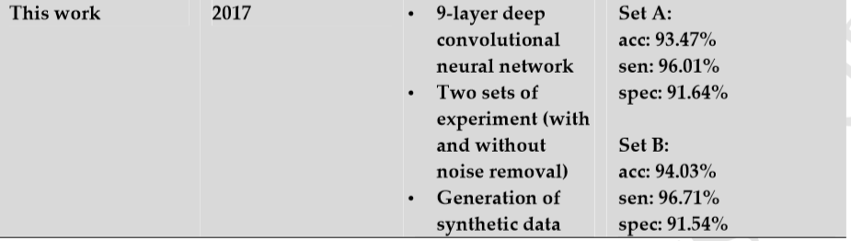

1. **Two Leads or One Lead ? In case of two leads .. how classification of two leads is merged to have final decision ?**
2. **Classes**

sub-divided into five categories namely non-ectopic, supraventricular ectopic, ventricular ectopic, fusion, and unknown beats